**Sustainable Supply Chain Performance Dashboard using Power BI**

**About the Project:**

In this project, all business supply chain-related tables are to be considered. This includes data on product types, SKUs, prices, availability, sales, revenue, customer demographics, stock levels, lead times, shipping details, supplier information, production volumes, defect rates, and transportation modes.

The primary objective is to analyse the performance of the supply chain and identify key metrics such as total revenue, average manufacturing cost, total products sold, most selling products, defect rates, shipping costs, and more.

The analysis would be visualized through a comprehensive Power BI dashboard comprising three pages, each focusing on different aspects of the supply chain, such as revenue analysis, supply chain performance, and defect rates. Let's start to know more about the project.

**Step-1**

* First download the Power BI Desktop in your laptop
* Open the Power BI and click on the Blank Report

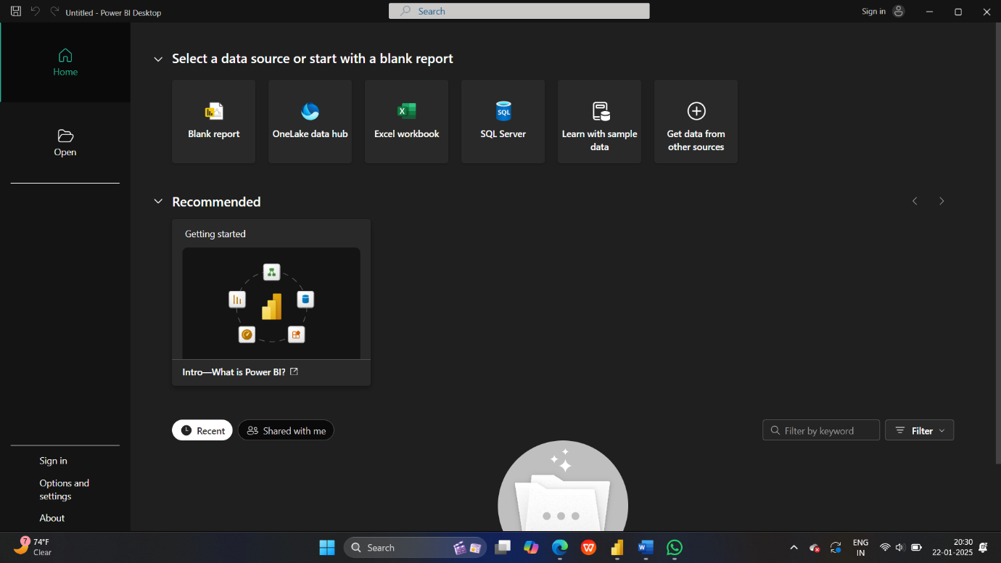

**Step-2**

After open the Blank Report import the data from SQL Server, CSV files etc…

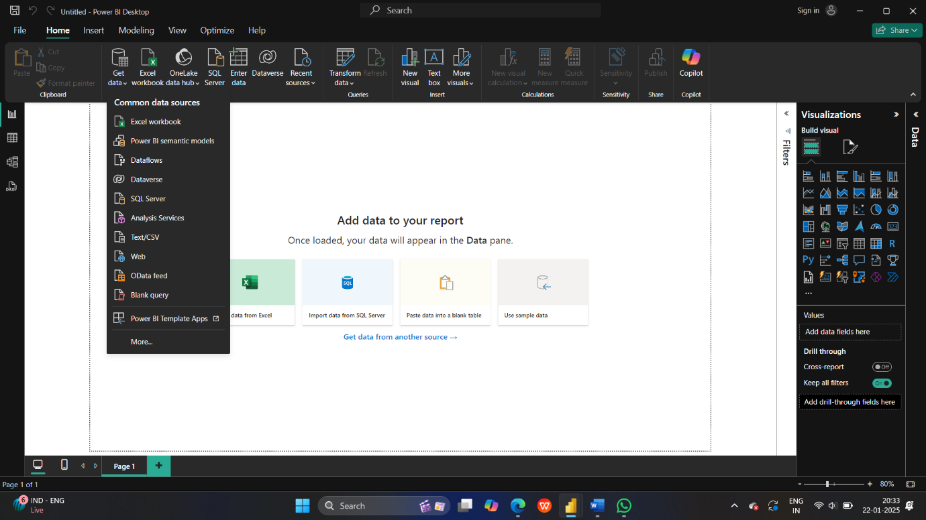

**Step-3**

See the above figure get data from different files and servers and I get the data from CSV File the file name is Sustainable supply chain performance dashboard using Power BI so the file contains Table

Table contains the rows the columns like Product type, SKU, Prize etc….

ETL-Extract Transform Load

Extract-Pull data from the source like-SQL Server, CSV file…

Transform-Data processing, Data cleaning

Load-For analysis

Now click on the transform data

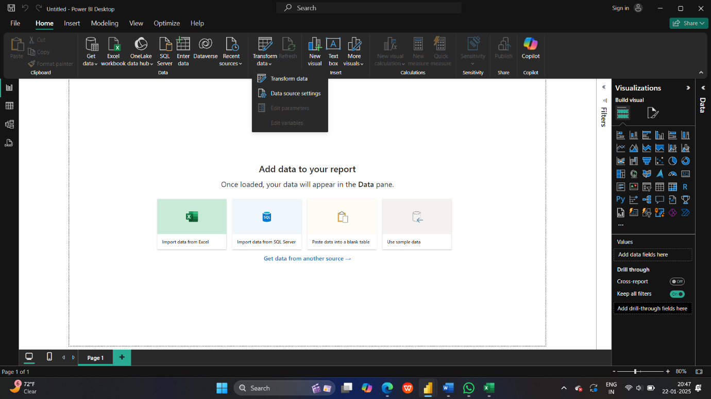

**Step-4**

Here we can see that transform data click on that we can see the below page and automatically open another tab which is transform data we can see the our import file details table and you created the another separate tables like Inventory type, Manufacturing able, Supplier table, Supply chain table And we remove the unwanted data columns in different tables

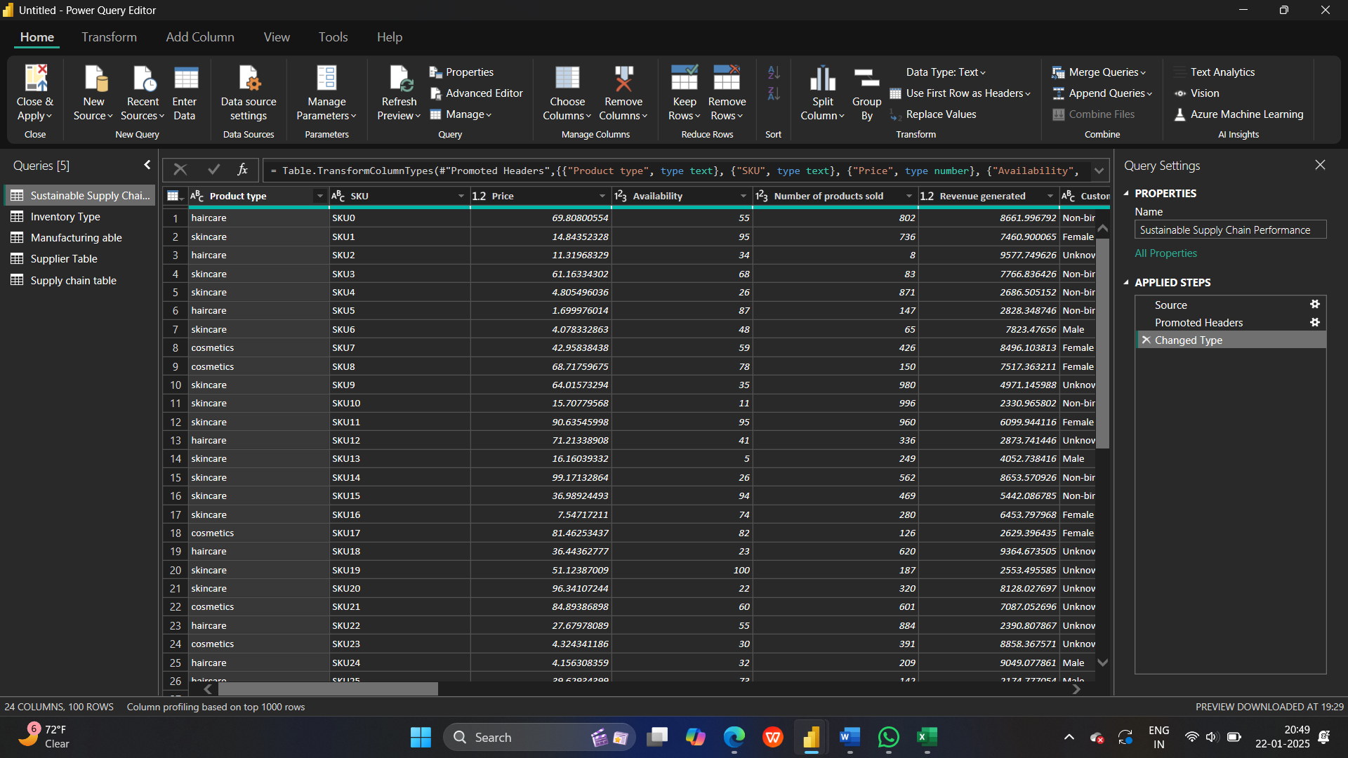

**Step-5**

After completing the process we click on the close & apply and this tables apply in the report we can see that in below image

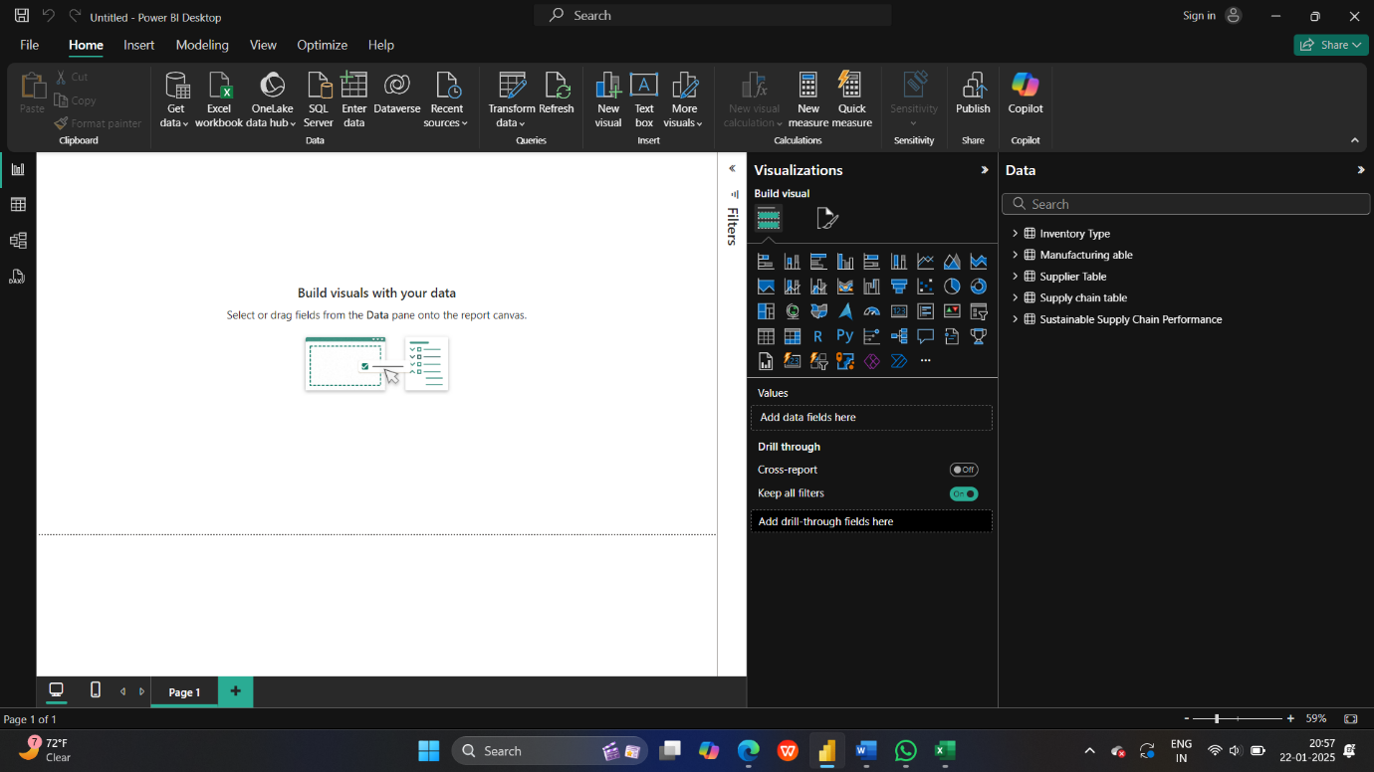

And this the first week Task I successfully import the data to Power BI and I create the different tables in the transform data and apply. We can see that the white Box type that is called the canvas.